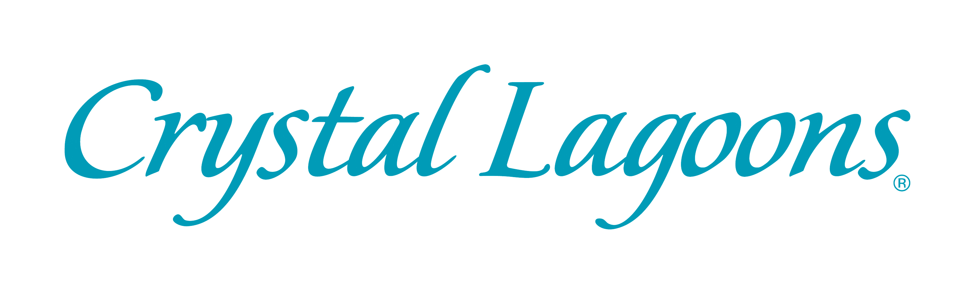

MEDIA RELEASE
DATE OF RELEASE: IMMEDIATE

THE MUCH-ANTICIPATED ENTRY OF THE WORLD LEADER IN WATER INNOVATION AND TECHNOLOGY, CRYSTAL LAGOONS, INTO THE SOUTH AFRICAN AND AFRICAN MARKETS IS SET TO TRIGGER A REAL ESTATE REVOLUTION ON THE CONTINENT

** This award-winning firm that has experienced an outstanding global growth in less than 7 years of operation has over 300 projects in different stages of development in 60 countries
** In the U.S. alone, there are more than twelve projects in development and more than 35 projects in negotiation with an estimated value of more than $20 billion dollars
** Crystal Lagoons has opened a regional office in Cape Town announcing millionaire business projections in Africa
** Crystal Lagoons holds two Guinness World Records for the largest crystalline lagoons in the world
** Crystal Lagoons’ unique, innovative technology is patented in 160 countries.
** Low construction and maintenance costs, combined with low energy consumption make each Crystal Lagoon a superlative proposition for property investors and developers, one that has triggered a revolution in the worldwide real estate industry.
*** New industrial patents for Crystal Lagoons have been obtained with Green Fast Track in the U.S., a preferred treatment for its great ecological contribution

In a breakthrough announcement for Africa, the multinational innovation and technology company, Crystal Lagoons, has set its sights on the African continent. The worldwide meteoric expansion of Crystal Lagoons’ innovation is revolutionizing the international real estate market. With an ever-expanding international presence, this award-winning firm has over 300 urban, tourist, public and industrial projects in different stages of development in 60 countries worldwide and offices in the United States, the Netherlands, the United Arab Emirates, Thailand, Spain, Brazil, Mexico, Australia, Turkey, China and Chile and soon Canada, Russia, Panama, India and Germany. The worldwide demand for the technology has grown exponentially. In the U.S. alone, there are more than twelve projects in development and more than 35 projects in negotiation with an estimated value of more than $20 billion dollars. After identifying South Africa as its steppingstone to the rest of the continent, Crystal Lagoons has opened a regional office in Cape Town with the aim of entering a key market and hastening its expansion in Africa.
Crystal Lagoons intends to achieve notable success in various African territories based on a substantial track record in other parts of the world. The company has experienced phenomenal global growth and following on from this rapid international uptake, it now looks to contribute to local African economies through its recreational and industrial applications.

Crystal Lagoons first rose to international prominence in 2007 when its iconic development in San Alfonso del Mar, Chile, was named the world’s largest manmade crystalline lagoon by the Guinness World Records (www.guinnessworldrecords.com). This sparkling water mass spans an incredible eight hectares.

The multinational has since surpassed this honour with its second Guinness World Record for an even larger, 12.5-hectare lagoon that is the main attraction of the Citystars Sharm El Sheikh tourist development, located in the middle of the desert in one of Egypt’s most luxurious coastal areas. The project productively uses brackish water derived from underground aquifers in the desert, which would otherwise not have any other alternative use!

These pioneering heights have been achieved thanks to Crystal Lagoons’ unique, innovative technology, which is patented in 160 countries. Its breakthrough innovations permit the economically and ecologically sustainable development of crystalline lagoons of unlimited size that are suitable for swimming and water sports. The massive lagoons are ideal for kayaking, paddle boarding, swimming and sailing in a safe and fun environment.

No other firm in the world is able to offer these exclusive amenities, which greatly add value to real estate developments. Besides the considerable recreational attraction, the low construction and maintenance costs, combined with low energy consumption make each Crystal Lagoon a superlative proposition for property investors and developers, one that has triggered a revolution in the worldwide real estate industry. Crystal Lagoons partners with real estate developers, industrial institutions and governmental entities to provide licensing for its state-of-the-art technology with applications that range from recreational to industrial and more. These immense bodies of water are an irreplaceable amenity for real estate and tourist projects worldwide. In fact, every development that boasts a Crystal Lagoon has seen a marked increase in the value of its property.
What truly sets Crystal Lagoons apart is that the enormous, incredibly clear bodies of water require only 2% of the energy usually required by conventional swimming pool technologies. What’s more, the lagoons have a water consumption level that is approximately half of that needed by a park and up to 30 times lower than a golf course! Additionally, the lagoons use up to 100 times fewer additives than traditional water filtration systems. In addition, Crystal Lagoons, always aiming at sustainability, has developed a technology (microfilm) that completely avoids water evaporation. This represents a great step further since the lagoons will no longer need additional water to compensate evaporation.
This same technology is also revolutionizing the international energy and water markets via industrial applications for the sustainable cooling of thermal power plants and other industrial facilities. In fact, Crystal Lagoons has obtained new industrial patents through the Green Fast Track program in the U.S., a preferred treatment due to its environmental contribution. In addition, it has pioneered other applications relating to water treatment processes for the mining industry, and the direct infiltration of water into underground aquifers.

These unrivalled innovations all began with influential scientist and entrepreneur, Fernando Fischmann, who founded Crystal Lagoons. Both Fischmann and the world-renowned company he has built have been the recipients of numerous awards. The vast array of accolades received by Fischmann and Crystal Lagoons includes Ernst & Young’s Entrepreneur of the Year; Innovator of the Year; “The Best New Business” in the USA; The Keys of Miami; The Environment Innovation Technology Award; Best Corporate Reputation; Best International Expansion; the two aforementioned Guinness World Records; and a score of others.

What is indeed crystal clear is that novelty and innovation come naturally to Crystal Lagoons. The unprecedented lagoons not only improve people's quality of life by bringing idyllic beach life and extraordinary waterscapes to urban areas and unimagined places, they also impact positively on livelihood in an environmentally and economically sustainable way. For both South Africa and Africa this new opportunity to take a dip into positive economic and tourism expansion is invaluable. Welcome, Crystal Lagoons!
ABOUT CRYSTAL LAGOONS
The international market has confirmed the export value of this technological innovation, with an explosive growth that in less than seven years has reached a sizable portfolio of 300 projects worldwide in the urban, tourist, public and industrial sectors, in various stages of development. Today the firm is associated with the major international real estate companies, with presence in five continents across 60 countries, including the United States, Saudi Arabia, United Arab Emirates, Egypt, Thailand, Indonesia, Singapore, Jordan, Mexico, Brazil, Colombia, Argentina, Peru, Paraguay, Uruguay, Chile, among others.
Patented in 160 countries, this technology is also revolutionizing the international energy and water market via its industrial applications for sustainable cooling of thermal power and industrial plants, and low cost water desalination and purification. Crystal Lagoons is also developing other industrial applications, for example for the desalination industry, where the innovative water treatment technology that allows considerably reducing reverse osmosis costs and providing desalination at very low costs. Also, other applications relate to water treatment processes for the mining industry, and the direct infiltration of water into underground aquifers.
Crystal Lagoons is the only firm in the world able to offer this innovative technology that enables the economically viable development of giant crystalline lagoons suitable for swimming and the practice of water sports. These immense bodies of water are an irreplaceable amenity for real estate and tourist projects worldwide, as they add differentiating value and caused a revolution in the worldwide real estate industry.
These giant crystalline lagoons only need water to compensate evaporation, and have a water consumption level of approximately half a park and up to 30 times lower than a golf course. Additionally, they use up to 100 times fewer chemicals than traditional disinfection and drinking water systems, and only 2% of the energy required by conventional filtering technologies.
For more information visit www.crystal-lagoons.com or
www.fernandofischmann.com
Crystal Lagoons South Africa is located in the Convention Tower, Foreshore, Cape Town.
Contact: Regional Manager, Alastair Sinclair, asinclair@crystal-lagoons.com
[ends]

PRESS RELEASE ISSUED BY:
Lauren Shantall (Pty) Ltd
Contact: Lauren Shantall 084 79 11 11 1 or lauren@laurenshantall.com
Release: January 2016

